
Business Question and Visualization Report

Date | 29 October 2026
Team ID | [Enter Team ID]
Project Name | Electric Vehicle Market Performance & Insights
Maximum Marks | 5 Marks

Visualization development refers to the process of creating graphical representations of data to facilitate understanding, analysis, and decision-making. The goal is to transform complex datasets into visual formats that are easy to interpret, enabling users to gain insights and make informed decisions. Visualization development involves selecting appropriate visual elements, designing layouts, and using interactive features to enhance the user experience. This process is commonly associated with data visualization tools and platforms, and it plays a crucial role in business intelligence, analytics, and reporting
Business Questions and Visualisation
The process involves defining specific business questions to guide the creation of meaningful and actionable visualizations in Tableau. Well-framed questions help in identifying key metrics, selecting relevant data, and building visualisation that provide insights.
Business questions, visualisations and insights (Tableau Public workbook – EV Market Executive Overview):
1. Which vehicle categories contribute the most to annual sales?
Visualization: Horizontal bar chart (Sheet 1) – SUM(annual_sales_units) by category.
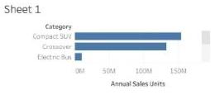
Insight: Two-Wheeler Scooters lead with 174.6 M units (11.3% of all sales), followed by Hatchback (154.9 M), Compact SUV and Sedan (153.4 M each). Electric Truck, Pickup Truck and Electric Bus each contribute < 1%.

2. Which manufacturers lead the market in terms of market share?
Visualization: Bar chart – Top 10 Manufacturers by Market Share % (Top-N filter on SUM of annual sales, percent-of-total table calculation).
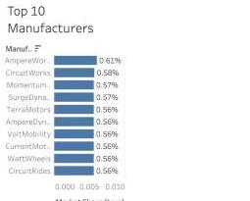
Insight: AmpereWorks leads with 0.61%, then CircuitWorks (0.58%), MomentumMobility and SurgeDynamics (0.57%). The top 10 of 200 manufacturers together hold only 5.7% – the market is highly fragmented.

3. What is the overall size and quality of the EV market?
Visualization: KPI Summary text table – Total Annual Sales, Avg Customer Rating, Avg Range.
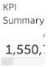
Insight: Total annual sales of 1,550,703,961 units across 200,000 EV models, an average customer rating of 4.09 / 5 and an average driving range of 324.5 km.

4. How is battery technology adopted across the EV market?
Visualization: Pie chart (Sheet 4) – share of annual sales by battery_type.
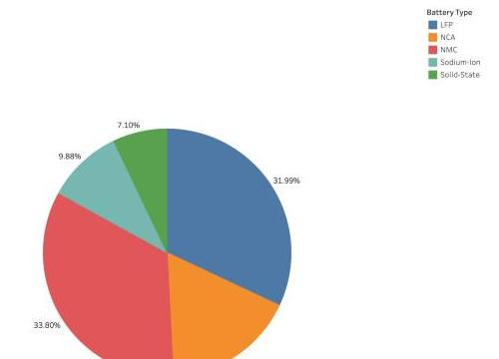
Insight: NMC (33.80%) and LFP (31.99%) dominate, followed by NCA (17.23%). Next-generation chemistries are still emerging: Sodium-Ion 9.88% and Solid-State 7.10%.

5. How does total driving range compare across battery types?
Visualization: Vertical bar chart (Sheet 6) – SUM(range_km) by battery_type, coloured by battery type.
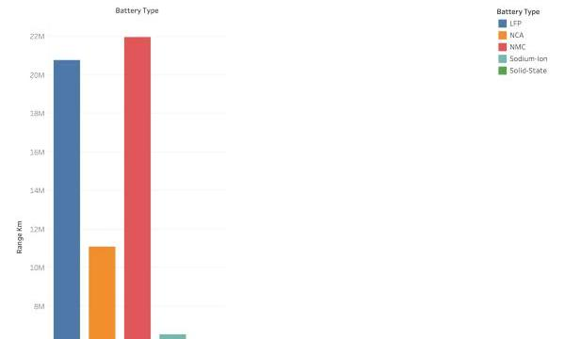
Insight: NMC (21.9 M km) and LFP (20.8 M km) deliver the highest total range because they power the most models; per vehicle the average range is almost identical (~324–326 km) for all chemistries, while Solid-State offers the longest cycle life (~3,000 cycles) and lowest 5-year degradation (7.4%).

6. Where are EVs manufactured and which countries produce the highest sales?
Visualization: Filled map (Story point 3) – manufacturing_country coloured by SUM(annual_sales_units).
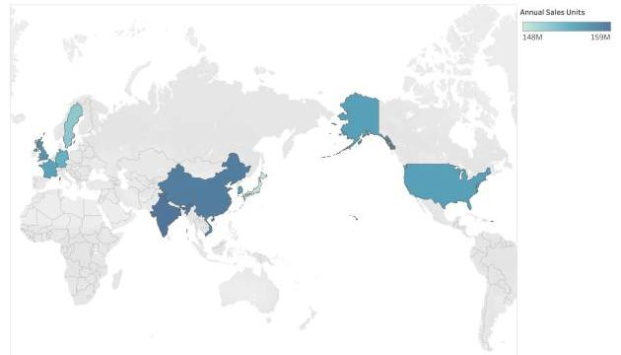
Insight: Production is evenly spread across 10 countries (148 M–159 M units each). India (159.2 M) and China (158.5 M) lead, Vietnam (157.3 M) and the UK (156.7 M) follow, and Japan is lowest (148.3 M).

7. Which vehicle categories offer the longest driving range?
Visualization: Sorted bar / text table (Sheet 5) – AVG(range_km) by category.
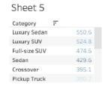
Insight: Luxury Sedans have the longest average range (550.6 km), followed by Luxury SUVs (524.8 km), Full-size SUVs (474.5 km) and Sedans (429.6 km). Two-Wheeler Scooters (105 km) and Three-Wheelers (130 km) are short-range urban vehicles.

8. How have annual sales changed across model years?
Visualization: Line chart (Sheet 3) – SUM(annual_sales_units) by model_year (2018–2026).
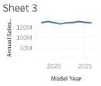
Insight: Sales are stable at roughly 166 M–177 M units per model year; the peak is 2019 (177.0 M) and 2024 (176.9 M), and the lowest is 2021 (165.8 M).

9. How does customer satisfaction vary across vehicle categories and battery types?
Visualization: Highlight table / heatmap (Sheet 8, Story point 5) – AVG(customer_rating) by category × battery_type.
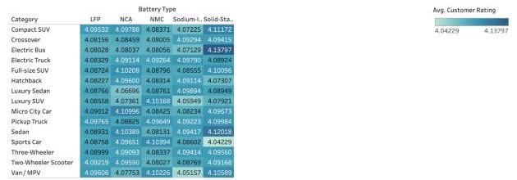
Insight: Ratings are consistently good (4.04–4.14). The highest is Electric Bus with Solid-State batteries (4.138) and the lowest is Sports Car with Solid-State (4.042); 57.7% of models are rated ‘Excellent’ (≥ 4).

Total: 9 business questions answered with 9 Tableau visualisations. Live workbook: https://public.tableau.com/app/profile/rajlaxmi.pandey/viz/Book2_17936085689820/Story1

